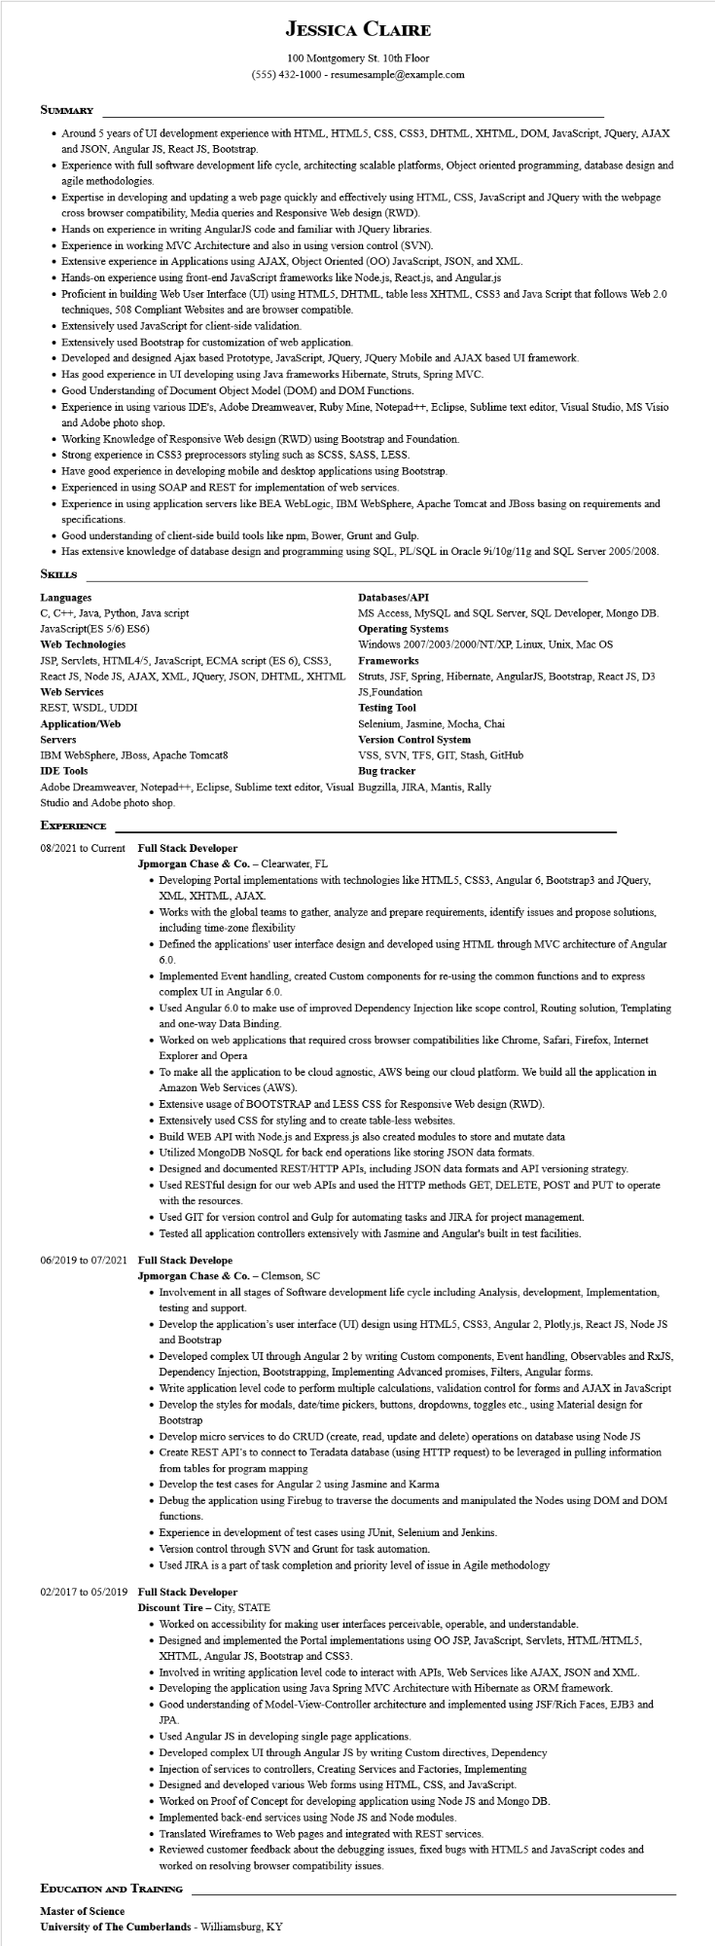
JESSICA CLAIRE
100 Montgomery St. 10th Floor (555) 432-1000 - resumesample@example.com
SUMMARY
• Around 5 years of UI development experience with HTML, HTML5, CSS, CSS3, DHTML, XHTML, DOM, JavaScript, JQuery, AJAX and JSON, Angular JS, React JS, Bootstrap.
• Experience with full software development life cycle, architecting scalable platforms, Object oriented programming, database design and agile methodologies.
• Expertise in developing and updating a web page quickly and effectively using HTML, CSS, JavaScript and JQuery with the webpage
cross browser compatibility, Media queries and Responsive Web design (RWD).
• Hands on experience in writing AngularJS code and familiar with JQuery libraries.
• Experience in working MVC Architecture and also in using version control (SVN).
• Extensive experience in Applications using AJAX, Object Oriented (OO) JavaScript, JSON, and XML.
• Hands-on experience using front-end JavaScript frameworks like Node.js, React.js, and Angular.js
• Proficient in building Web User Interface (UI) using HTML5, DHTML, table less XHTML, CSS3 and Java Script that follows Web 2.0 techniques, 508 Compliant Websites and are browser compatible.
• Extensively used JavaScript for client-side validation.
• Extensively used Bootstrap for customization of web application.
• Developed and designed Ajax based Prototype, JavaScript, JQuery, JQuery Mobile and AJAX based UI framework.
• Has good experience in UI developing using Java frameworks Hibernate, Struts, Spring MVC.
• Good Understanding of Document Object Model (DOM) and DOM Functions.
• Experience in using various IDE's, Adobe Dreamweaver, Ruby Mine, Notepad++, Eclipse, Sublime text editor, Visual Studio, MS Visio and Adobe photo shop.
• Working Knowledge of Responsive Web design (RWD) using Bootstrap and Foundation.
• Strong experience in CSS3 preprocessors styling such as SCSS, SASS, LESS.
• Have good experience in developing mobile and desktop applications using Bootstrap.
• Experienced in using SOAP and REST for implementation of web services.
• Experience in using application servers like BEA WebLogic, IBM WebSphere, Apache Tomcat and JBoss basing on requirements and specifications.
• Good understanding of client-side build tools like npm, Bower, Grunt and Gulp.
• Has extensive knowledge of database design and programming using SQL, PL/SQL in Oracle 9i/10g/11g and SQL Server 2005/2008.
SKILLS
Languages
C, C++, Java, Python, Java script
JavaScript(ES 5/6) ES6)
Web Technologies
JSP, Servlets, HTML4/5, JavaScript, ECMA script (ES 6), CSS3,
React JS, Node JS, AJAX, XML, JQuery, JSON, DHTML, XHTML Web Services
REST, WSDL, UDDI
Application/Web
Servers
IBM WebSphere, JBoss, Apache Tomcat8
IDE Tools
Databases/API
MS Access, MySQL and SQL Server, SQL Developer, Mongo DB. Operating Systems
Windows 2007/2003/2000/NT/XP, Linux, Unix, Mac OS Frameworks
Struts, JSF, Spring, Hibernate, AngularJS, Bootstrap, React JS, D3 JS,Foundation
Testing Tool
Selenium, Jasmine, Mocha, Chai
Version Control System
VSS, SVN, TFS, GIT, Stash, GitHub Bug tracker
Adobe Dreamweaver, Notepad++, Eclipse, Sublime text editor, Visual Bugzilla, JIRA, Mantis, Rally
Studio and Adobe photo shop.
EXPERIENCE
08/2021 to Current Full Stack Developer
Jpmorgan Chase & Co. - Clearwater, FL
• Developing Portal implementations with technologies like HTML5, CSS3, Angular 6, Bootstrap3 and JQuery, XML, XHTML, AJAX.
• Works with the global teams to gather, analyze and prepare requirements, identify issues and propose solutions, including time-zone flexibility
• Defined the applications' user interface design and developed using HTML through MVC architecture of Angular 6.0.
• Implemented Event handling, created Custom components for re-using the common functions and to express complex UI in Angular 6.0.
• Used Angular 6.0 to make use of improved Dependency Injection like scope control, Routing solution, Templating and one-way Data Binding.
• Worked on web applications that required cross browser compatibilities like Chrome, Safari, Firefox, Internet Explorer and Opera
• To make all the application to be cloud agnostic, AWS being our cloud platform. We build all the application in Amazon Web Services (AWS).
• Extensive usage of BOOTSTRAP and LESS CSS for Responsive Web design (RWD).
• Extensively used CSS for styling and to create table-less websites.
• Build WEB API with Node.js and Express.js also created modules to store and mutate data
• Utilized MongoDB NoSQL for back end operations like storing JSON data formats.
• Designed and documented REST/HTTP APIs, including JSON data formats and API versioning strategy.
• Used RESTful design for our web APIs and used the HTTP methods GET, DELETE, POST and PUT to operate with the resources.
• Used GIT for version control and Gulp for automating tasks and JIRA for project management.
• Tested all application controllers extensively with Jasmine and Angular's built in test facilities.
06/2019 to 07/2021 Full Stack Develope
Jpmorgan Chase & Co. - Clemson, SC
• Involvement in all stages of Software development life cycle including Analysis, development, Implementation, testing and support.
• Develop the application's user interface (UI) design using HTML5, CSS3, Angular 2, Plotly.js, React JS, Node JS and Bootstrap
• Developed complex UI through Angular 2 by writing Custom components, Event handling, Observables and RxJS, Dependency Injection, Bootstrapping, Implementing Advanced promises, Filters, Angular forms.
• Write application level code to perform multiple calculations, validation control for forms and AJAX in JavaScript
• Develop the styles for modals, date/time pickers, buttons, dropdowns, toggles etc., using Material design for Bootstrap
• Develop micro services to do CRUD (create, read, update and delete) operations on database using Node JS
• Create REST API's to connect to Teradata database (using HTTP request) to be leveraged in pulling information from tables for program mapping
• Develop the test cases for Angular 2 using Jasmine and Karma
• Debug the application using Firebug to traverse the documents and manipulated the Nodes using DOM and DOM functions.
• Experience in development of test cases using JUnit, Selenium and Jenkins.
• Version control through SVN and Grunt for task automation.
• Used JIRA is a part of task completion and priority level of issue in Agile methodology
02/2017 to 05/2019 Full Stack Developer
Discount Tire - City, STATE
• Worked on accessibility for making user interfaces perceivable, operable, and understandable.
• Designed and implemented the Portal implementations using OO JSP, JavaScript, Servlets, HTML/HTML5, XHTML, Angular JS, Bootstrap and CSS3.
• Involved in writing application level code to interact with APIs, Web Services like AJAX, JSON and XML.
• Developing the application using Java Spring MVC Architecture with Hibernate as ORM framework.
• Good understanding of Model-View-Controller architecture and implemented using JSF/Rich Faces, EJB3 and JPA.
• Used Angular JS in developing single page applications.
• Developed complex UI through Angular JS by writing Custom directives, Dependency
• Injection of services to controllers, Creating Services and Factories, Implementing
• Designed and developed various Web forms using HTML, CSS, and JavaScript.
• Worked on Proof of Concept for developing application using Node JS and Mongo DB.
• Implemented back-end services using Node JS and Node modules.
• Translated Wireframes to Web pages and integrated with REST services.
• Reviewed customer feedback about the debugging issues, fixed bugs with HTML5 and JavaScript codes and worked on resolving browser compatibility issues.
EDUCATION AND TRAINING
Master of Science
University of The Cumberlands - Williamsburg, KY

